It helps people affected by PD improve well-being, deal with symptoms and connect with others in the Parkinson’s community.
All with PD and family and friends are welcome - no dance experience is necessary.
Helping people with Parkinson’s disease through the power of dance!
Your first class is free so join us for a fun, fulfilling experience!
Dance for PD is endorsed and supported by the Parkinson Council and Penn Medicine

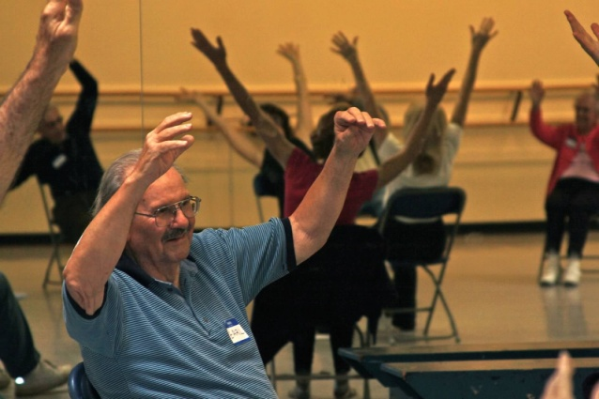
The Rock School West
1510 Paoli Pike, West Chester
Tuesdays from 1:15-2:30
Spring Session I March 19th to April 23rd (No Class March 26)
Spring Session II April 30th to May 28rd

Registration: Karen Lynch (610-524-1556 or FXLKSL@verizon.net) or Rock School (610-431-4321)
On-line registration https://app.etapestry.com/cart/TheParkinsonCouncil/cart2/index.php

Five Week Session $35 – Support Person is FREE! (drop-in rates available)

